**Lab 1 – Requirements**

**A.** Given data in the **yearly_request.csv**, please complete the following tasks.

1. Import data in .csv file to **requests** data frame in R
2. Export the histogram of **number of requests** to jpeg file

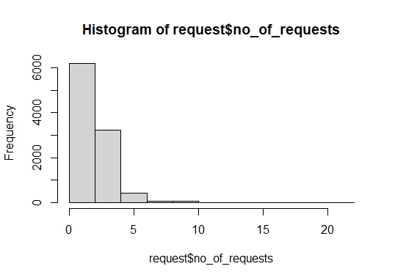

1. Add a column **per_request** to dataset and exports the modified dataset to “requests_modified.txt” file



1. Extract the second, third, and fourth column of the **requests** data frame

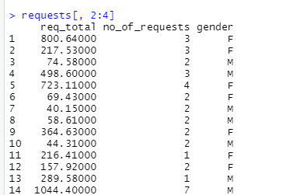

1. build an empty character vector of the same length as **requests** and group the customers according to the request amounText

   Description automatically generatedt
2. Summary of requests

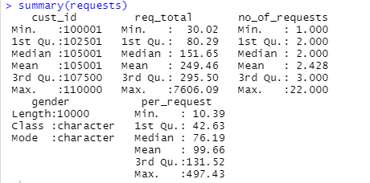

1. Calculate and show total of request value

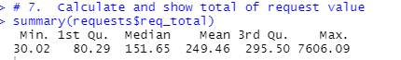

**The result report must be included in a document which has:**

- All necessary commands used to do task

- And output screen of command result

**B. Write commands**

* 1. Create a vector **v** contain values from 1 to 50



* 1. Calculate the total value of all elements in **v**



* 1. List all elements which has value greater than 10 and less than 40



* 1. Create a new vector from vector **v**. Element value in the new vector is two times of element value in **v**



* 1. Write the code to generate *data (****with norm = 60, mean = 0, sd = 0.6****)* and show this data like the below figure

